# **RideWise: Customer Churn Prediction & Analytics Engine**

## **Complete Project Documentation (Mid‑Level MLOps, 2.5‑Week Delivery)**

**Industry / Sector**: Transportation Technology | European Mobility | Customer Analytics | MLOps  
**Duration**: 2.5 Weeks  
**Deployment**: AWS EC2 (Single Instance) + CI/CD

## **1. Company Overview**

RideWise is a mobility technology company operating across five major European cities (London, Berlin, Amsterdam, Barcelona, and Milan). With more than 200,000 active riders and over 800,000 monthly trips, customer retention has become a strategic priority due to rising churn, increased competition, and inefficient manual analytics processes.

**Current State**:

* 25% quarterly churn among active customers
* £8M annual revenue loss attributed to churn
* Low promotion effectiveness (12% uptake)
* Delays in customer insights due to manual analysis
* No predictive capability for identifying at-risk customers

**Mission**: Shift from reactive analytics to predictive and proactive customer retention, reducing churn and improving strategic and operational decisions.

## **2. Business Challenge**

### **Revenue Impact:**

* **Customer Churn**: 50,000 customers lost yearly
* **Lost Revenue**: LTV of £160 → £8M yearly loss
* **Marketing Inefficiency**: £2.5M in low-performing promotions

### **Operational Challenges:**

* No churn early warning system
* Generic marketing with poor targeting
* No real-time scoring capability
* Insights take weeks to produce
* Outdated segmentation updated manually

### **Strategic Needs:**

* Predict churn 30 days in advance at 80%+ accuracy
* Deliver 3–5 actionable customer segments
* Real-time prediction API
* Data-driven retention strategy
* Scalable and maintainable ML pipeline

## 

## 

## **3. Rationale for the Project**

Customer retention significantly boosts profitability. Predictive churn identification allows for targeted, cost-efficient interventions.

### **Business Value:**

* Estimated **40% churn reduction** → £3.2M in savings
* Improved promotion targeting → £1.5M in savings
* Increased customer LTV by 25% → ~£4M value
* Access to real-time operational and strategic insights

### **Technical Capabilities Delivered:**

* End-to-end churn prediction workflow
* Actionable segmentation engine
* FastAPI prediction service deployed on AWS EC2
* Lightweight CI/CD pipeline for updates
* CloudWatch-based monitoring
* HTML business analytics dashboard

### **Learning Outcomes:**

* ML pipeline design and delivery
* Customer analytics techniques
* FastAPI development
* Docker packaging and deployment
* MLOps implementation at mid-level complexity

## **4. Project Objectives**

### **Core Deliverables**

**Week 1: Data & Analytics Foundation**

* Customer segmentation (K-Means)
* Full EDA + churn behavior exploration
* Feature engineering pipeline (RFM + behavior metrics)
* Churn pattern insights report

**Week 2: Model Development & MLOps Setup**

* Train three churn models (LR, RF, XGBoost)
* MLflow experiment tracking
* FastAPI prediction endpoints
* Dockerization of the API service
* Model evaluation documentation

**Final Half-Week: Deployment & Monitoring**

* Deploy FastAPI on AWS EC2
* Lightweight CI/CD pipeline
* CloudWatch logging + basic error & CPU alerts
* Business analytics dashboard
* Final documentation & handover

### 

### 

### **Success Metrics**

| **Metric** | **Target** | **Business Impact** |
| --- | --- | --- |
| Churn Prediction AUC | > 0.80 | Identify majority of churners |
| Precision @ Top 15% | > 70% | High-value retention focus |
| API Latency | < 500ms | Real-time operational use |
| Uptime | 99% | Stable service |
| Customer Segments | 3–5 groups | Actionable strategies |

### 

## **5. Technology Stack**

### **Development & ML:**

| **Component** | **Technology** | **Purpose** |
| --- | --- | --- |
| **Language** | Python 3.9+ | Core development |
| **ML Libraries** | scikit-learn, XGBoost, pandas, NumPy | Model development |
| **Feature Engineering** | Custom pipeline | Consistent training/serving features |
| **Clustering** | K-Means | Segmentation engine |
| **Database** | SQLite (local) | Development use |

### 

### 

### 

### 

### 

### **MLOps & Deployment:**

| **Component** | **Technology** | **Purpose** |
| --- | --- | --- |
| **Experiment Tracking** | MLflow (local server) | Track models |
| **API Framework** | FastAPI | Serve predictions |
| **Containerization** | Docker | Reproducible builds |
| **CI/CD** | GitHub Actions (lightweight) | Auto-build + deploy |
| **Cloud Platform** | AWS EC2 | Host API |
| **Monitoring** | CloudWatch | Logs + alerts |

### **Visualization & Documentation:**

| **Component** | **Technology** | **Purpose** |
| --- | --- | --- |
| Dashboards | Plotly + HTML | Business insights |
| Documentation | Markdown | Technical docs |

## 

## 

## 

## 

## 

## 

## **6. Project Architecture**

### **Architecture Diagram**

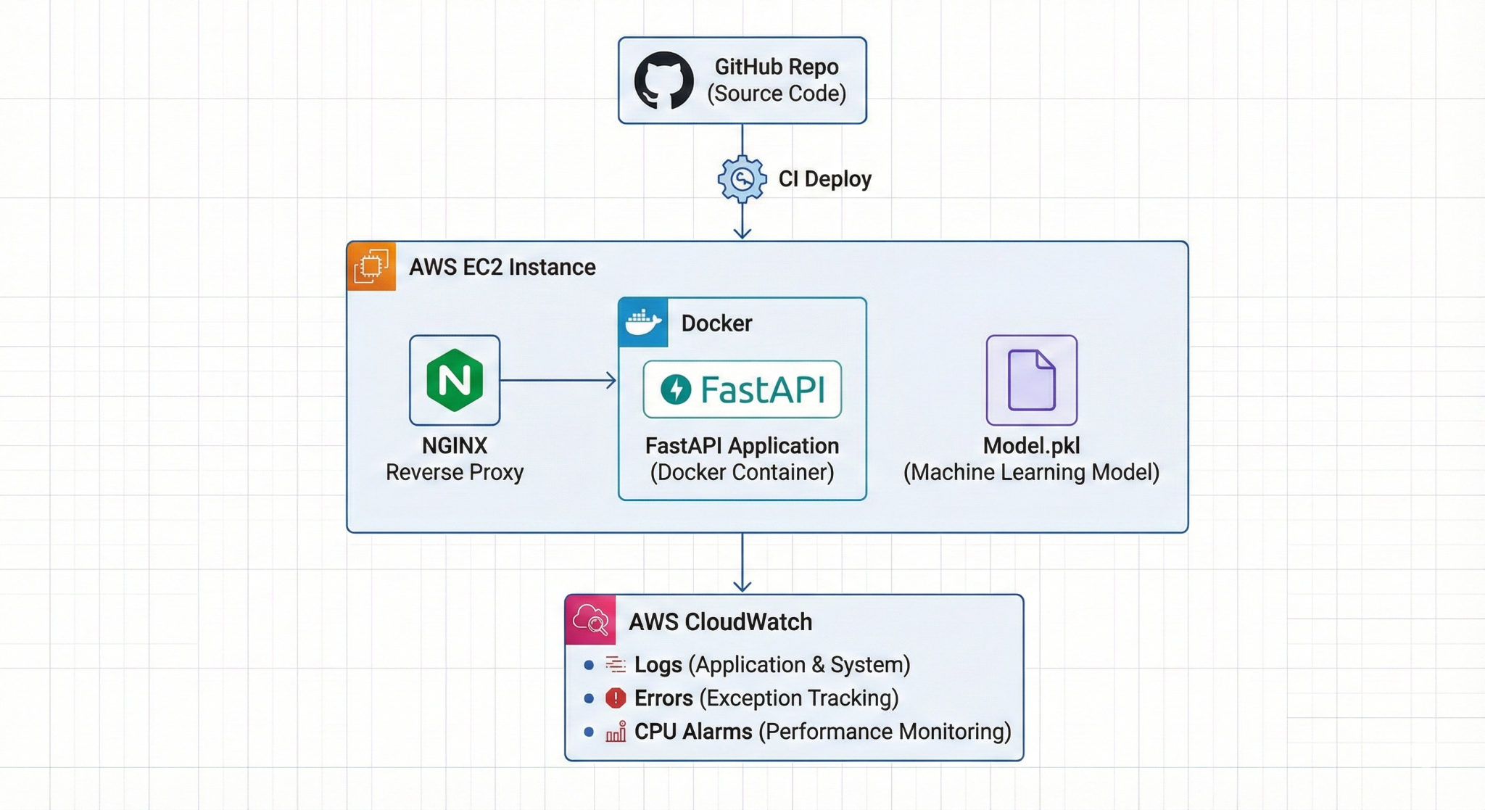

### **ML Pipeline Flow**

### **1. Data Processing and Feature Engineering**

The process begins with raw data, which is transformed into meaningful features for your model.

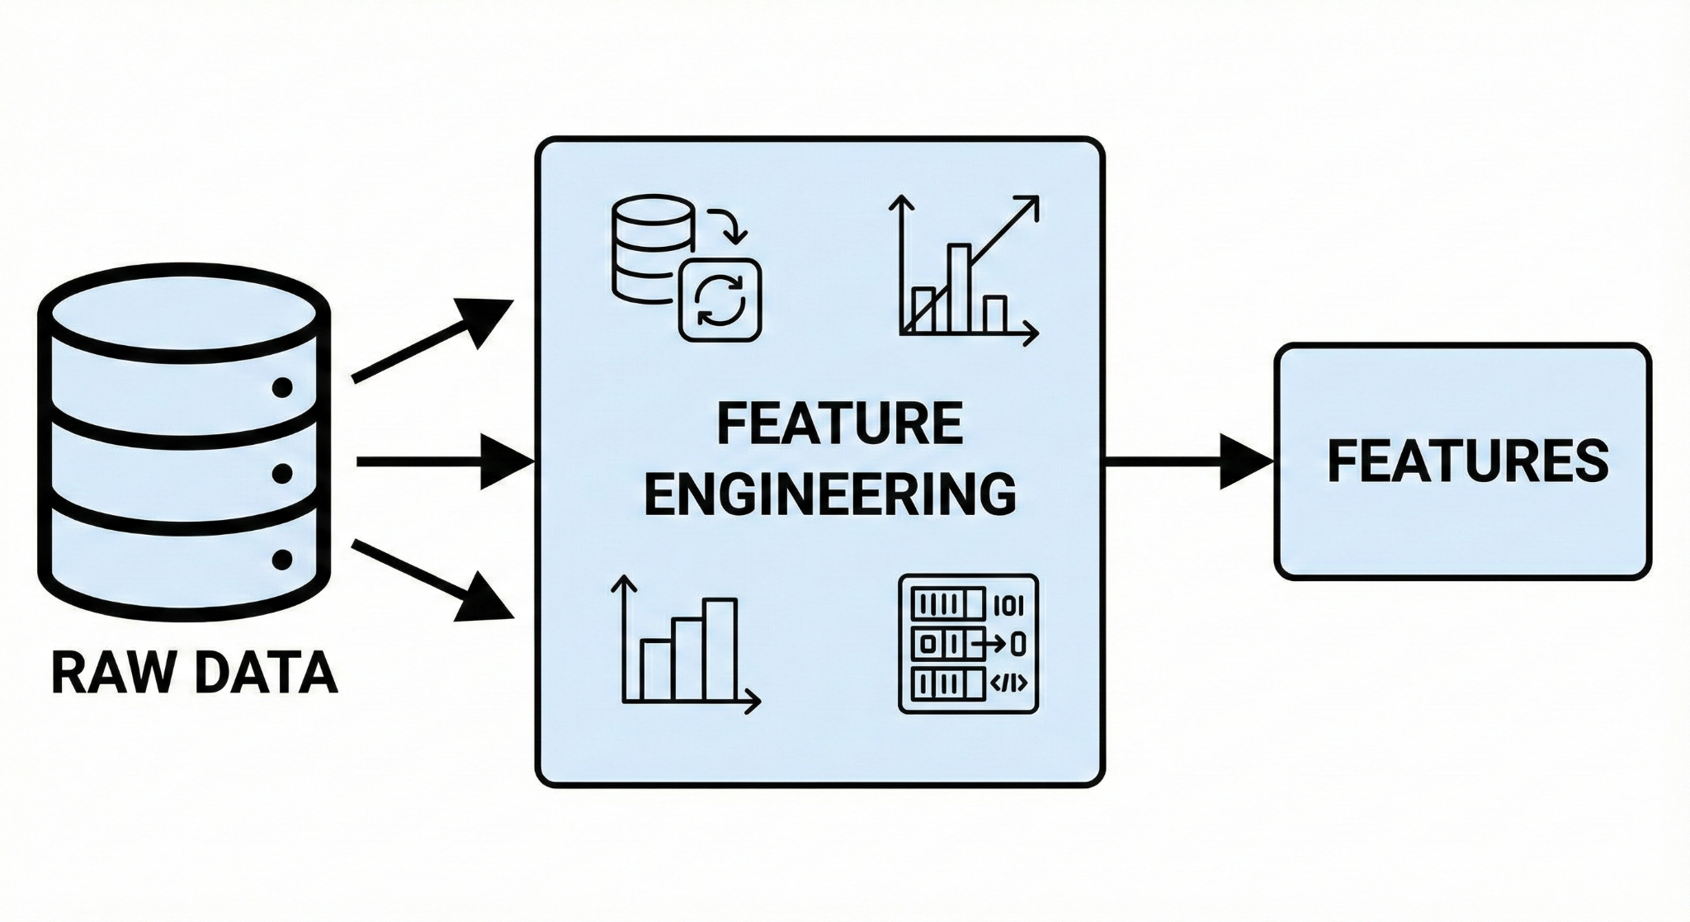

### 

### **2. Model Training and MLflow Logging**

Next, the features are used to train a machine learning model. The training process, along with its metrics, parameters, and the model artifact itself, is logged to an MLflow tracking server.

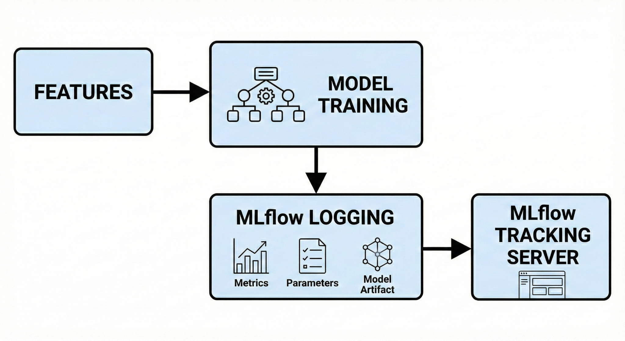

### **3. Model Registry and Service Creation**

The trained model is then registered in the MLflow Model Registry. From there, it's loaded into a FastAPI application to create a prediction service.

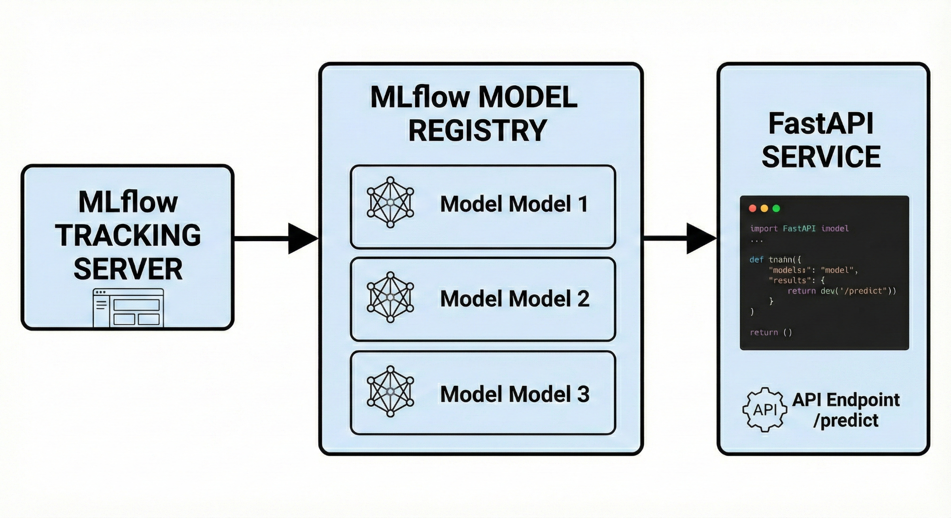

### **4. Containerization and Deployment**

Finally, the FastAPI service is packaged into a Docker image and deployed to an Amazon EC2 instance, making your model's predictions accessible via an API endpoint.

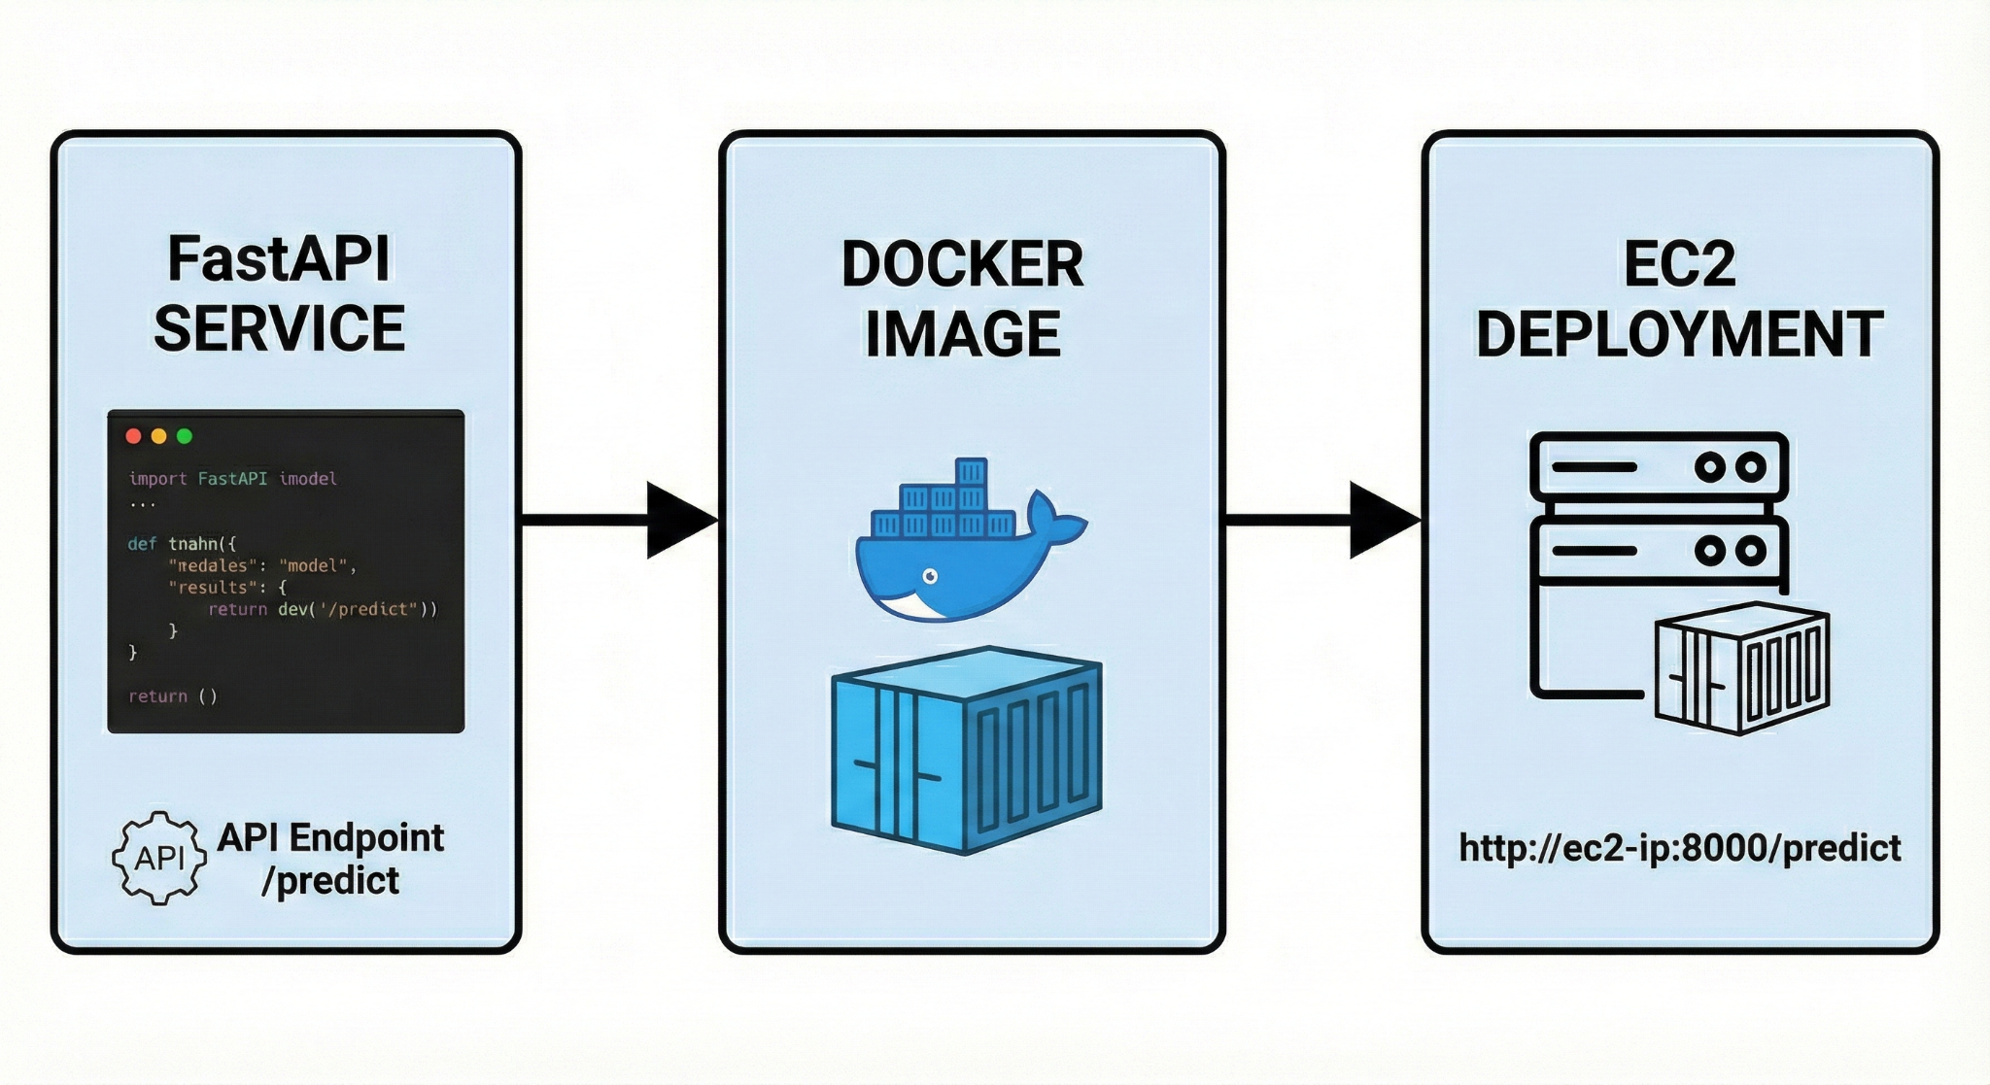

## **7. Week-by-Week Breakdown**

### **Week 1: Foundation (Days 1–7)**

* Environment setup (Python, Docker, Git)
* Data exploration & cleaning
* RFM + behavioral feature engineering
* K-Means clustering (3–5 segments)
* Churn behavior analysis
* EDA insights report (6–8 pages)

### **Week 2: Modeling & MLOps Setup (Days 8–14)**

* Train Logistic Regression, Random Forest, XGBoost
* Model comparison + selection
* MLflow experiment logging
* Build FastAPI service with /predict & /health
* Add Pydantic validation
* Docker packaging + local container testing
* Basic CI pipeline (build + copy file to EC2)

### **Final Half-Week: Deployment & Monitoring (Days 15–18)**

* Deploy FastAPI on AWS EC2 (single instance)
* Set up NGINX reverse proxy
* Configure CloudWatch logging + CPU/error alerts
* Build Plotly HTML business dashboard
* Final documentation set (API, deployment, monitoring, insights)

## **8. Technical Challenges & Solutions**

### **Challenge 1: Class Imbalance**

* Use class weights
* Evaluate precision@15% instead of accuracy

### **Challenge 2: Feature Consistency**

* Single feature engineering script used in training + inference

### **Challenge 3: Latency**

* Optimize model (e.g., tuned XGBoost)
* Use lightweight EC2 instance + NGINX

### 

### 

### **Challenge 4: Monitoring**

* CloudWatch alarms for CPU, 5xx errors, API failure

## **9. Success Metrics & Evaluation**

### **Model Metrics**

| **Metric** | **Target** |
| --- | --- |
| AUC | > 0.80 |
| Precision@15% | > 70% |
| F1 Score | > 0.70 |

### **Business Metrics**

| **Impact Area** | **Target** |
| --- | --- |
| Churn Reduction | 40% |
| Promotion Uptake | 25% |
| Customer LTV | £200 |

### **Technical Metrics**

| **Metric** | **Target** |
| --- | --- |
| Latency | < 500ms |
| Uptime | 99% |
| Retraining Time | < 2 hours |

### 

## 

## **10. Monitoring & Alerting Strategy**

**CloudWatch Alarms:**

* High CPU (>70% for 5 mins)
* API failure rate (>5% errors)
* Container restarts

**Logs:**

* Application logs streamed to CloudWatch
* Prediction logs stored locally or S3

## **11. Deliverables Checklist**

### **Code & Models**

* Feature engineering pipeline (RFM + behavior metrics)
* Segmentation model (K-Means, 3–5 clusters)
* Churn models trained (Logistic Regression, Random Forest, XGBoost)
* Final selected churn model packaged for deployment
* FastAPI prediction service implemented
* Docker image built and tested locally

### 

### 

### 

### **MLOps & Deployment\*\***

* MLflow tracking
* CI pipeline
* EC2 deployment
* CloudWatch monitoring

### **Documentation**

* EDA report
* API documentation
* Deployment & monitoring guides
* Business dashboard
* Final presentation deck

## **12. Learning Outcomes**

### **Technical Skills**

* ML workflow execution
* Customer analytics & segmentation
* API development with FastAPI
* Mid-level MLOps practices
* Docker & EC2 deployment
* Monitoring with CloudWatch

### 

### **Business Skills**

* Retention strategy interpretation
* Marketing efficiency analysis
* Data-driven decision support

### **Soft Skills**

* Project planning
* Communication & documentation
* Collaboration workflows

## **13. Risk Management**

| **Risk** | **Probability** | **Impact** | **Mitigation** |
| --- | --- | --- | --- |
| Low model accuracy | Medium | High | Improve feature set |
| EC2 deployment issues | Low | High | Pre-deployment testing |
| Data quality problems | High | Medium | Validation scripts |
| Timeline pressure | Medium | Medium | Scope prioritization |